Shot on Stats
A Statistical Game & Player Outcome Predictor for Soccer
Incubator Pitch Document — Draft v1

1. What This Is
Shot on Stats predicts the outcome of upcoming Premier League soccer matches and generates individual stat projections for every player on both teams. Predictions are computed by a statistical Elo rating model, not by AI. A separate AI layer takes the model's output and writes a clear, readable explanation of why it predicted what it did. Both upcoming fixtures and past results (with predicted-vs-actual comparisons) are shown publicly on the website.

2. Incubator Requirements — How Shot on Stats Meets Them
Requirement | How Shot on Stats Satisfies It
Data-driven | All predictions are computed from real Premier League data (fixtures, results, team and player statistics) pulled from API-Football and stored in our own database — not static or guessed data.
Connects to MySQL | A MySQL database stores teams, players, fixtures, Elo ratings, and both game- and player-level predictions. The website is powered entirely by queries against this database.
AI-enhanced feature | An AI layer reads the Elo model's numeric output and the underlying stats, then generates a natural-language explanation of the prediction for each match. A second, independent AI model reviews each explanation for accuracy before it's published — turning raw numbers into something a fan can understand, with a built-in quality check.
Usable by the public | A public website displays upcoming match predictions, full player stat projections, AI explanations, and a historical record of predicted-vs-actual outcomes for past games.
Monetization strategy | Freemium subscription model, gated by breadth not depth: free users get the full experience (player projections, AI explanation) on 3 user-chosen matches per week, supported by ads; paid users get every match across every covered league, ad-free.

3. How Predictions Are Made

3.1 Team Outcome — Elo Rating System
Each team is assigned an Elo rating, the same rating system used in chess and widely used in sports analytics (e.g., FiveThirtyEight's soccer forecasts, ClubElo). The core idea: a team's rating rises when it beats a higher-rated opponent and falls when it loses to a lower-rated one, with the size of the change scaled to how surprising the result was. Elo-based models are a well-established, reasonably accurate approach for soccer outcome forecasting — but it's important to be precise about what the model actually outputs: a probability for each possible outcome (home win, draw, away win), not a guaranteed winner. Soccer has meaningful inherent uncertainty, so even a well-calibrated model will be "wrong" some of the time by design — that's expected, not a flaw.
- Team ratings are sourced directly from ClubElo.com's free, publicly available API (api.clubelo.com), which maintains live, expert-calculated Elo ratings for thousands of clubs going back decades — rather than building and maintaining our own rating engine from scratch, which would be a much larger undertaking for a project at this stage.
- ClubElo's Fixtures endpoint (api.clubelo.com/Fixtures) already provides calculated outcome probabilities for upcoming matches, including a full breakdown by goal difference — this gives us a credible, third-party-validated probability for each match without having to derive the Elo-to-probability math ourselves.
- Our own layer sits on top of these probabilities: combining them with API-Football's fixture, team, and player data to power the player-level projections and the AI explanation, and storing everything in our own MySQL database so the product isn't just a live pass-through of someone else's numbers.
- Data sources are mixed deliberately: ClubElo for team strength/outcome probability, API-Football for fixtures, results, and all player-level statistics. This does mean club names need to be matched between the two sources (e.g., "Man City" vs. "Manchester City"), which is a known integration detail to handle during setup.
- For the pitch stage, this architecture is described rather than fully built — the working prototype (if pursued) would come after the pitch, once a team is assembled.

3.2 Player-Level Stat Projections — Simulation Methodology
Player projections are not just a flat season average — they're generated through a simulation approach commonly used in real sports analytics (the same family of methods behind published football forecasting models like Dixon-Coles), so the word "simulation" reflects an actual technique rather than just a label. The process runs in four steps for every player, for every stat category tracked:
- Step 1 — Baseline rate: each player's stat (goals, shots, assists, cards, etc.) is converted to a per-90-minutes rate using their season totals, so playing time differences between players are accounted for fairly.
- Step 2 — Opponent adjustment: that rate is scaled up or down based on the upcoming opponent's defensive strength, using the opponent's Elo rating and goals-conceded rate — a forward facing a weak defense gets a higher expected rate than one facing a strong defense.
- Step 3 — Recent form weighting: the season-long rate is blended with the player's rate over their last 5 matches (a weighted average favoring the season rate but responsive to current form), so a player on a hot or cold streak isn't judged purely on season-long numbers.
- Step 4 — Simulation: the final adjusted rate becomes the expected value (λ) of a Poisson distribution — the standard statistical model for count-based events like goals or shots in football analytics. Instead of just reporting that single expected value, the system runs a Monte Carlo simulation: thousands of random draws from that distribution, representing thousands of simulated versions of the match. The displayed projection is the average across all simulated outcomes, which is more robust than a single formula-based guess and naturally supports showing a likely range (e.g., "most likely 0–1 goals") rather than a false-precision single number.
For players with insufficient season data — new signings, players returning from injury, or those with very few appearances — the simulation is not run and the player is instead marked "not enough data," so every number shown is backed by real history rather than a guess.

3.3 Mathematical Foundations
The prediction engine rests on a chain of well-established statistical techniques, each feeding into the next. All constants (home-field advantage, the Elo-to-goals scaling, and the recent-form blend weight) are automatically calibrated via the process in Section 10 to minimize error against historical results, rather than left as permanent guesses.

Elo rating → match outcome probability
The first step converts each team's current Elo rating into an expected match outcome, using the standard Elo expected-score formula adapted for soccer:
E_home = 1 / (1 + 10^(−(EloHome − EloAway + HomeAdv) / 400))
The base of 10 and the divisor of 400 are the original constants chosen when Elo was designed for chess, set so that a 400-point rating gap corresponds to a 10:1 expected-score ratio. What matters is not the specific numbers but the shape of the curve: it is logistic (an S-curve), not linear — a 0-to-100-point rating gap should matter more to the outcome than a 900-to-1000-point gap, since at the extremes the outcome is already close to certain. This is why Elo uses a logistic curve rather than a straight-line formula.
Worked example — Arsenal (Elo 1932) vs. Chelsea (Elo 1874), HomeAdv ≈ +100: (1932 − 1874 + 100) / 400 = 158 / 400 = 0.395, so E_home = 1 / (1 + 10^−0.395) = 1 / 1.4027 ≈ 0.713.
In chess, E is a weighted average of win (1), draw (0.5), and loss (0) — a single number is enough. Soccer has three separately meaningful outcomes, so 0.713 alone cannot be split into a win/draw/loss breakdown without more information. That is the reason the system needs the next step.

Expected goals → Poisson distribution
The Elo advantage is converted into an expected goal difference using a scaling constant C (how many Elo points equal one goal of advantage):
Expected goal difference = (EloHome − EloAway + HomeAdv) / C
With C ≈ 200 (calibrated), the 158-point advantage from the example above becomes 158 / 200 ≈ 0.79 expected-goal advantage. This is split around a league-average baseline of roughly 1.3 goals/team/match: λ_home = 1.3 + 0.79/2 ≈ 1.4, and λ_away = 1.3 − 0.79/2 ≈ 0.9. These are the λ (lambda) values — the expected-goals parameters — used directly in the Section 5.4 simulation visualization; the 1.4 and 0.9 figures shown there are not chosen for display purposes, they come directly from this calculation.
C is not derivable from first principles — like HomeAdv, it is an empirical constant that must be fit against real data, which is exactly what Section 10's calibration process does.
Goals in soccer are a good fit for the Poisson distribution because scoring approximates a rare, independent counting process over a fixed time window: each attack has a small, roughly constant chance of becoming a goal, attempts are numerous over 90 minutes, and (to a reasonable approximation) a goal does not much change the odds of the next attack succeeding. The Poisson probability mass function gives the probability of exactly k occurrences, given expected value λ:
P(k) = (λ^k × e^−λ) / k!
Worked table for Arsenal (λ = 1.4):
Goals (k) | Calculation | Probability
0 | e^−1.4 | 24.7%
1 | 1.4 × e^−1.4 | 34.5%
2 | (1.4² / 2) × e^−1.4 | 24.2%
3 | (1.4³ / 6) × e^−1.4 | 11.3%
4 | (1.4⁴ / 24) × e^−1.4 | 4.0%
5+ | 1 − sum of above | 1.4%
This closely matches the illustrative distribution shown in the Section 5.4 mockup (22/34/27/12/4/1%) — the small differences come from the opponent-strength and recent-form adjustments layered on in Section 3.2, steps 2–3, on top of this base Poisson calculation.

Combining two Poisson distributions into a match outcome
Each team's goal count is treated as statistically independent of the other's, so the probability of any specific scoreline (home scores i, away scores j) is the product of each team's individual probability:
P(home = i, away = j) = P_home(i) × P_away(j)
From there: P(draw) is the sum of P(i, i) for every possible i (both teams score the same number of goals); P(home win) is the sum of P(i, j) for every case where i > j; P(away win) is the sum of P(i, j) for every case where i < j.
Worked example, continuing Arsenal (λ = 1.4) vs. Chelsea (λ = 0.9): summing P_home(k) × P_away(k) across k = 0, 1, 2, 3... gives a draw probability of approximately 27.2%. Carrying the same summation through for home-win and away-win cases gives roughly 48.6% and 24.2% — a 49/27/24 split, close to the 52/23/25 shown in the Section 5.1 mockup.
Known simplification, stated honestly: independent Poisson slightly under-predicts how often certain low-scoring results happen — real matches show scorelines like 0–0, 1–0, and 1–1 slightly more often than the independent-Poisson math alone predicts, because teams' scoring is not perfectly independent in practice (e.g., a team protecting a 1–0 lead plays more defensively, which suppresses further scoring by both sides at once). Published forecasting models, including the Dixon-Coles approach referenced in Section 3.2, correct for this with a small adjustment factor applied only to low scorelines. For the pitch/MVP stage, the model uses plain independent Poisson without this correction — a known, named simplification rather than a hidden gap, and a natural next refinement once the core system is working.

Why simulate, rather than compute the exact distribution directly
For a single number like team goals, the exact win/draw/loss split is directly computable via the summation above — no random sampling is strictly required. Monte Carlo simulation (Section 3.2, step 4) is used instead for two concrete reasons: first, once player-level stats are added — 8 stat categories across roughly 22–30 players per match, with realistic correlations between them (a player who scores more also tends to take more shots) — computing the exact joint probability distribution by hand becomes impractical, while random sampling handles this complexity automatically, one random draw per stat per player, repeated many times. Second, simulation produces the full spread of outcomes as a natural byproduct, not just a single average — which is exactly what the Section 5.4 distribution visualization and "most likely 0–1 goals" range messaging need.
Why 10,000 trials specifically: a Monte Carlo estimate's standard error shrinks with the square root of the number of trials:
SE ≈ √(p(1−p) / n)
At n = 10,000 and p = 0.5 (the worst case for uncertainty), SE ≈ √(0.25 / 10,000) ≈ 0.005 — about ±0.5 percentage points, which is precise enough for a percentage displayed rounded to the nearest whole number. Increasing to 100,000 trials would only tighten this to about ±0.16 points, a small gain for ten times the computation — so 10,000 is a deliberate accuracy/cost trade-off, not an arbitrary round number.

Player-level projection — the four-step formula in full
Step 1 — Baseline rate, converting a player's season totals to a per-90-minutes rate so playing-time differences don't distort the comparison: rate_90 = (season total ÷ minutes played) × 90.
Step 2 — Opponent adjustment, scaling that rate by the upcoming opponent's defensive strength relative to the league average: rate_adj = rate_90 × (league-average goals conceded per match ÷ opponent's goals conceded per match). A weaker-than-average defense makes this ratio greater than 1, boosting the attacking player's expected rate; a stronger defense pulls it below 1.
Step 3 — Recent form blend, a weighted average between the season-long adjusted rate and the same rate computed over just the player's last 5 matches: λ_player = w × rate_adj(season) + (1 − w) × rate_adj(last 5), with w weighted toward the season rate (e.g., w ≈ 0.7) so that a single unusually good or bad match doesn't swing the projection too far. Like C and HomeAdv, w is itself one of the constants tuned by the Section 10 calibration process.
Step 4 — Simulation, exactly as described above: this final λ becomes the Poisson parameter for that specific player-and-stat combination, and the same Monte Carlo sampling process produces its distribution and displayed projection.

Calibration: the Brier score in full
Brier score = (1/N) × Σ (forecast_i − outcome_i)²
forecast_i is the predicted probability for match i (e.g., 0.713 for an Arsenal win), and outcome_i is 1 if that outcome actually happened and 0 if it didn't, averaged across N historical matches from the Section 9 backtest.
Why squared error specifically, rather than plain (absolute) error: squaring penalizes confident-but-wrong predictions far more heavily than being confidently right rewards it. A forecast of 0.9 that turns out wrong costs 0.81 in squared error but only 0.9 in absolute error — this asymmetry is what makes the Brier score reward genuine calibration (being right about how confident to be, not just right on average) rather than rewarding blind confidence.
Brier score | Interpretation
0.0 | Perfect forecaster — impossible in practice given soccer's real uncertainty
0.25 | Equivalent to always guessing 50/50 on a binary outcome — the no-skill baseline
Below 0.25 | Indicates genuine predictive skill; lower is better
Section 10's automated calibration process computes this score across a grid of candidate values for C, HomeAdv, and w against the Section 9 historical backtest, and adopts whichever combination scores lowest — a brute-force but fully reproducible search, since the same historical data will always produce the same best combination. The chosen values, along with the accuracy improvement they produced, are logged to the calibration_log table (Section 6) for audit purposes.

Prediction Flow, Visualized
The diagram below summarizes the full chain of steps above in one view — Elo ratings flow down through the team-level path (gray) to produce the win/draw/loss prediction and goal distribution, while the player-level rate calculation (teal, detailed in Section 3.2) joins in at the same Monte Carlo simulation step:
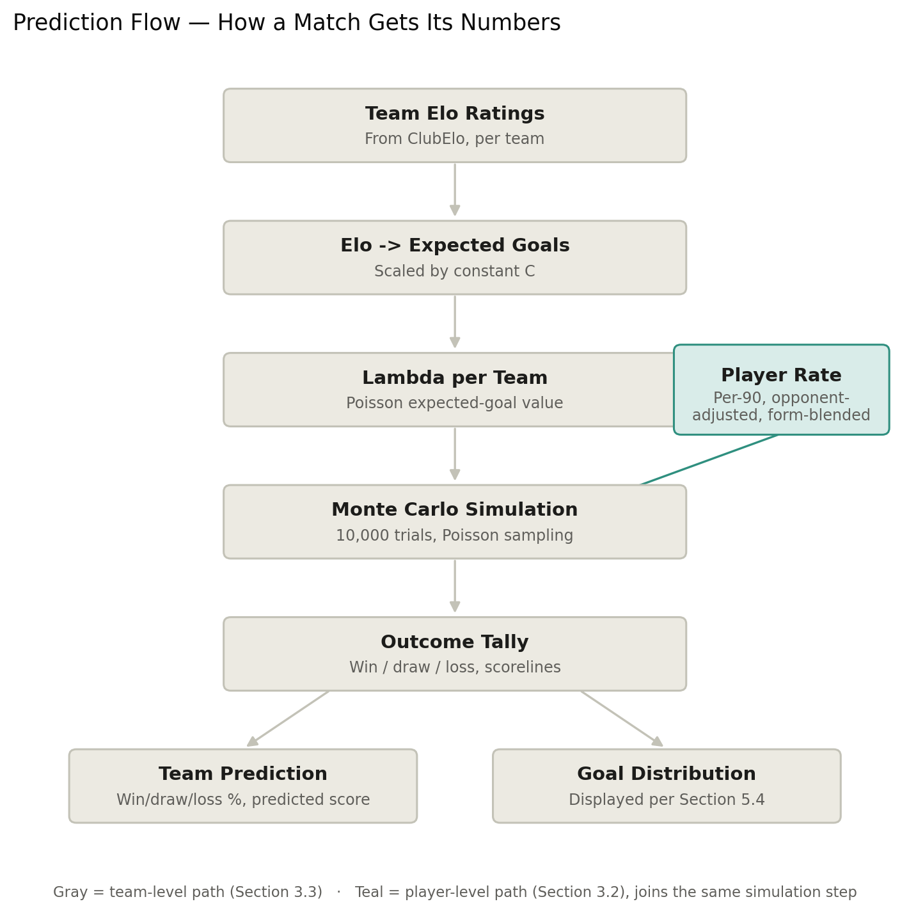

4. The AI Layer — Explanation, Not Prediction
The AI does not generate the prediction itself — the Elo model and player-stat formulas do that, so every number shown on the site is traceable back to real data and a defined calculation. The AI's job is purely to explain the result in plain language: summarizing why the model favors one team, which players are projected to stand out, and how the historical head-to-head or recent form factored in.
- Input to the AI: the computed team probabilities, player projections, and the underlying stats that fed them.
- Output: a short, readable explanation per match, written for a fan audience rather than a data audience.
- Current implementation: an existing third-party AI API (e.g., Claude). This is a deliberate, practical starting point — as the project matures, this could be replaced by a custom-trained model built specifically on our own prediction data, reducing dependency on an external API and allowing more tailored explanations over time.
- Quality control: each explanation is checked by a second, independent AI model before publishing — a separate review pass that flags anything factually inconsistent with the underlying stats (e.g., a claim that doesn't match the numbers) before it ever reaches the site. Using a different model for review, rather than having the same model check its own work, reduces the chance both steps share the same blind spot.
- Cost at scale: a Premier League week has roughly 10 matches, so generating one explanation per match is only about 10 AI calls a week — inexpensive even on paid API pricing. The bigger cost driver is the second review pass (doubling calls to ~20/week) and, if projections are ever explained per player rather than per match, that would scale with squad size instead of fixture count. For a single-league pilot this stays well within a few dollars a month; it's worth tracking as a cost line if the product expands to multiple leagues or per-player explanations.

5. What's Displayed

5.1 Match Page — Team Level
- Predicted winner (or draw) and predicted scoreline
- Win / Draw / Loss probability, shown as percentages (sourced from ClubElo), not just a single winner guess
- Each team's current Elo rating, so viewers can see why one side is favored
- Recent form (last 5 results) for both teams
- Head-to-head record between the two teams
- The AI-generated explanation paragraph, shown after the second AI review pass

5.2 Match Page — Player Level (full squad, both teams)
For every player: Goals, Assists, Shots, Shots on Target, Passes, Pass Accuracy %, Tackles, Fouls, and Yellow/Red Cards, each shown as a projected stat line for the upcoming match (e.g., "0.4 goals, 2.1 shots") rather than a raw season total. Players marked "not enough data" are shown clearly rather than given a guessed number.
- Default view: a compact summary row per player (name, projected goals, shots, cards), sorted by projected goals so the most relevant players surface first.
- Expandable detail: clicking a player reveals the full stat breakdown, keeping the default page usable rather than overwhelming with 22+ full rows of every stat at once.

5.3 Past Results View
- Same layout as the match page, but with "Predicted" and "Actual" shown side by side for both team outcome and player stats — this is what builds the site's visible, honest track record over time.

5.4 Simulation Visualization
Rather than showing only the final projected number, the site visualizes the simulation that produced it — in the style of data-driven sports graphics (e.g., shot-map visuals that animate every attempt, then land on a bold headline total). Applied here: each team gets its own projected total, shown as a bold headline number alongside the full distribution of outcomes from its Monte Carlo trials — not a single combined figure, so viewers can see how each team's projection was actually built, not just the end result.
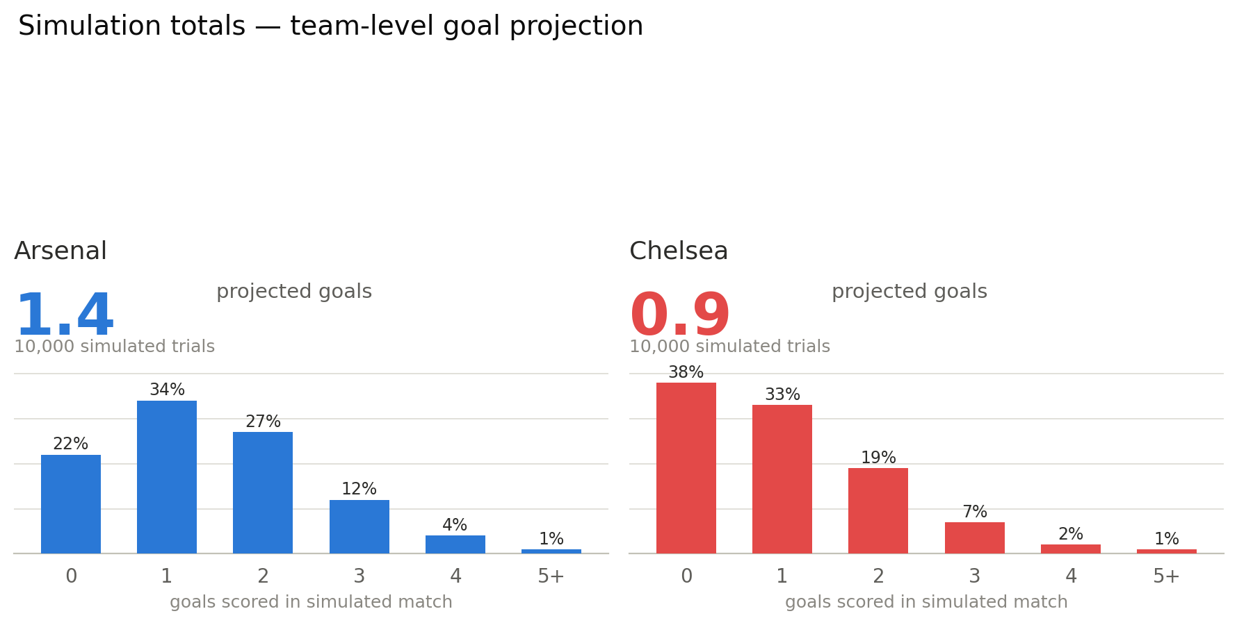
Example mockup: Arsenal's projected 1.4 goals and Chelsea's projected 0.9 goals are each the average of 10,000 simulated match outcomes, with the bar chart underneath showing exactly how those trials were distributed (e.g., Arsenal scored 0 goals in 22% of simulations, 1 goal in 34%, and so on) — giving each team's total a visible, honest basis instead of an unexplained single number.
- Reinforces that "simulation" is a real technique, not just a label — visually distinct from a competitor simply printing a static stat.
- Per-team framing (rather than one combined figure) matches how the underlying model actually works — each team's attack is simulated against the opponent's defense independently, so each deserves its own total and its own distribution.
- Applies to every tracked stat, not just goals: the same headline-number-plus-distribution treatment is used for shots, cards, assists, and every other stat category from Section 3.2 — goals is shown here only as the illustrative example.
- Scope for the pitch stage: described and mocked up here, not required to be fully built — the underlying simulation data already needed for the projection (Section 3.2) is what would drive this visual if built.

5.5 Access
- Clean, simple public interface — no login required to browse predictions; account creation only needed for the paid tier.

5.6 Custom Match Sandbox
A separate, clearly-labeled sandbox mode lets users type in their own hypothetical Elo ratings and home-field advantage for any two teams — real or made-up — and run the exact same simulation engine from Section 3.3 against those custom values. Nothing entered here touches the real database: no fixture, prediction, or player record is created or modified, so this feature is entirely disconnected from the data that Section 9's backtesting validates against.
- Separate quota from real matches: free-tier users get 3 sandbox uses per day, tracked independently from the 3-matches-per-week real-prediction cap (Section 7) — running a custom simulation never counts against, or is counted by, the real match limit. Premium removes this cap as well, consistent with how it removes the real-match cap.
- Zero marginal API cost to run: since inputs are user-typed rather than pulled from API-Football or ClubElo, the simulation itself doesn't touch the Section 12 API budget — the 3-per-day quota exists to keep usage predictable and to bound the AI explanation cost below, not because the simulation itself is expensive.
- AI explanation is opt-in, not automatic: adjusting sliders and re-running the simulation is free within the daily quota, but generating an AI explanation of a custom result requires a separate, deliberate "Explain this" click — this keeps AI usage tied to genuine interest rather than firing on every slider drag.
- The same second-model review pass from Section 4 still checks each sandbox explanation before it's shown, for consistency — sandbox explanations get the same quality bar as real match explanations, even though they're private and never published.

6. Data Architecture
The diagram below shows how data moves through the whole system end to end — from the two external data sources, through the daily sync and database, into the simulation and AI layers, out to the website, and back through the calibration feedback loop:
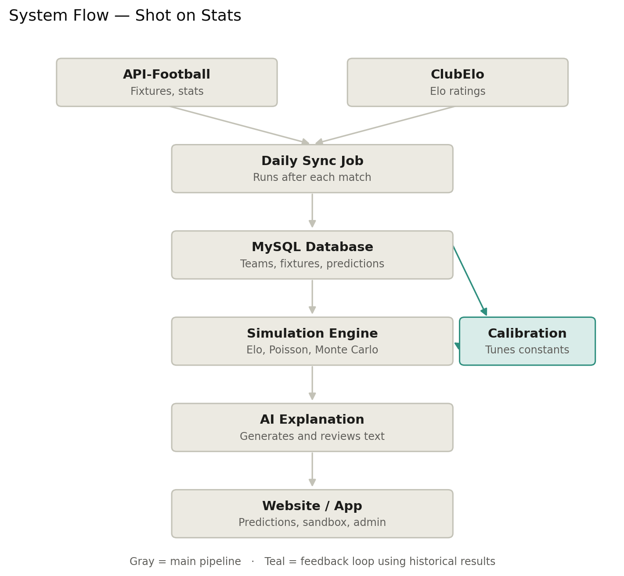
Table | Holds
teams | Team id, name, current Elo rating, league
players | Player id, team id, name, position
player_season_stats | Season totals/averages per player — goals, assists, shots, passes, cards, etc.
fixtures | Upcoming and completed matches, teams, date, actual result once played
predictions | Fixture id, predicted winner, predicted score, win probability, AI explanation
player_predictions | Fixture id, player id, projected stat line across all tracked categories
Data is synced from API-Football on a scheduled daily job — team stats, player stats, and fixture results — then the Elo ratings and player projections recompute the same day, before the AI explanation step runs for any newly-scheduled fixtures.

7. Monetization Strategy
Tier | Access
Free | 3 matches per week, chosen by the user from that week's full slate; full experience on those matches — team prediction, complete player stat projections, and AI explanation; supported by ads
Premium (subscription) | Every match, every league, every week — same full feature set as Free (player projections, AI explanations), just without the 3-match cap, and no ads
A second revenue stream sits alongside subscriptions: display advertising on the free tier. Placement isn't locked down yet — for now, ad slots are open to any standard position (banner, between match cards, sidebar, etc.), with the actual layout likely to change once real usage patterns are seen. The one fixed rule is category, not position: ads must not overlay or obscure predictions, and the ad-free experience itself acts as an upgrade incentive toward Premium.
- Ad network: a standard programmatic network (e.g., Google AdSense) is sufficient at this scale — no custom ad-sales relationships needed to launch.
- Category restriction: gambling and sports-betting ads are excluded from the ad configuration, since the product's positioning is statistical predictions, not betting facilitation — keeping the ad content consistent with what the app actually is.
Additional future revenue paths (not required for launch): a season-long API/data license for other developers, and one-off bundles for major tournaments.

8. Risks & Limitations
- Predictions are probabilities, not guarantees. Even a well-calibrated Elo model will be "wrong" some of the time by design — soccer has real inherent uncertainty, and the site's messaging should reflect this honestly rather than implying certainty.
- The AI review pass reduces, but doesn't eliminate, the risk of an inaccurate or misleading explanation slipping through — it's a safeguard, not a guarantee.
- Data quality varies by source: club name mismatches between ClubElo and API-Football, and incomplete stats for new or rarely-used players, are known integration challenges to handle carefully rather than ignore.
- This is a pitch-stage concept. The architecture and data sources described are real and usable, but a working prototype has not been built yet — that would follow team formation.

9. Testing & Validation
Before launch, the prediction model is validated using backtesting: running the simulation against past World Cup tournaments, where every match's real outcome is already known, and comparing the model's predictions to what actually happened. This gives a way to measure accuracy without needing live, in-progress data, and without waiting for a real season to play out. This is an internal testing process only — backtested historical predictions are used to evaluate and tune the model, not shown to the public on the live site.
- Historical team stats and results from prior World Cups are pulled the same way live data would be (API-Football, with Elo ratings for the relevant historical period), so the test conditions mirror how the system runs in production.
- For each historical match, the model generates a prediction — win/draw/loss probability, predicted score, and player-level projections — using only the data that would have been available before that match was played, so the test doesn't unfairly use hindsight.
- Each prediction is then compared against the actual recorded result: was the predicted winner correct, how close was the predicted score, and how well-calibrated were the probabilities overall (e.g., did matches given a 70% win probability actually get won roughly 70% of the time).

9.1 Worked Example (Illustrative)
To make the testing process concrete, here is what one backtested match looks like end to end. Numbers are illustrative, not real model output, since no prototype has been built yet.
Field | Model prediction (pre-match) | Actual result
Match | 2022 World Cup Final — Argentina vs France | —
Win / Draw / Loss probability | Argentina 45% / Draw 27% / France 28% | Argentina won (on penalties)
Predicted score | Argentina 2–1 | 3–3 (90 min), Argentina won on penalties
L. Messi — projected goals | 0.5 | 2
K. Mbappé — projected goals | 0.4 | 3
This single-match view is what gets rolled up across an entire tournament to produce accuracy metrics (e.g., percentage of correct outcome predictions, average score error, calibration of the win-probability numbers) — the tournament-level summary is the actual testing output; the match-level table above is one row within it.

10. Continuous Improvement — Automated Calibration
The model's core structure (the Elo-plus-simulation approach in Section 3) stays fixed, but a handful of its internal constants — the home-field adjustment, the weighting between season-long and recent-form stats, and the strength of the opponent-defense adjustment — can be automatically tuned over time using the same backtesting process from Section 9, rather than left at manually chosen defaults indefinitely.
- What gets tuned: only the model's numeric constants, never its structure. The formula stays the same, explainable calculation described in Section 3.2 — calibration adjusts its inputs, not its design.
- How it works: predictions are regenerated against historical matches using a range of candidate values for each constant (e.g., testing home advantage at 4%, 5%, 6%, 7%...), each batch is scored using a standard accuracy measure (a Brier score, already used for track-record reporting in Section 8), and whichever combination of values produces the most accurate predictions becomes the new default.
- No AI involved in this step: this is a straightforward statistical search, not a judgment call — it's fully reproducible, since re-running the same backtest against the same data always finds the same answer.
- Every change is logged: the old value, the new value, and the accuracy improvement that justified the change are recorded, so updates stay auditable rather than appearing as silent, unexplained shifts in behavior.
- Cadence: run once per season, or after a meaningful batch of new results accumulates (e.g., every few gameweeks) — not continuously, since re-tuning after every single match risks overreacting to short-term noise rather than genuine long-term signal.
- Scope for the pitch stage: described as a planned enhancement building on the testing process in Section 9, not required for launch.

11. Hosting & Deployment
A lightweight, low-cost stack is enough for this project's scale — all free or near-free at a single-league pilot's traffic and data volume:
Layer | Suggested Option | Why
Website (frontend) | Vercel or Netlify | Free static hosting; live at a public URL within minutes, no server management
Backend/API | Railway or Render | Free/low-cost tier for a small backend app that queries MySQL and serves data to the site
MySQL database | Railway, Clever Cloud, or PlanetScale | Free-tier hosted MySQL; a season of one league's data is well within free storage limits
This is a practical setup detail rather than something the pitch itself depends on — it becomes relevant once a team is assembled and starts building.

12. League & Competition Coverage
Coverage is scoped deliberately around what the free-tier API budget (100 requests/day on API-Football, no published limit on ClubElo) can sustainably support, using an event-driven sync design: API calls are only made when a match actually finishes, rather than on a fixed schedule regardless of activity. This keeps daily usage tied to real match volume instead of league count alone.

12.1 Domestic Club Leagues
Ten major domestic leagues are targeted, staggered onto the platform one at a time rather than launched simultaneously:
- Premier League (England), La Liga (Spain), Bundesliga (Germany), Serie A (Italy), Ligue 1 (France), Eredivisie (Netherlands), Primeira Liga (Portugal), Belgian Pro League, Scottish Premiership, MLS (USA).
Consideration | Detail
Combined weekly matches | ~90–100 across all 10 leagues, but spread across Friday–Monday rather than concentrated on one day
Busiest single day (typically Saturday) | ~35–45 matches finishing
Estimated API calls on busiest day | ~40–55 — comfortably within the 100/day free limit
Onboarding a new league (one-time bootstrap) | ~100–150 calls total, split across several non-matchdays so no single day exceeds the free limit

12.2 National Team Competitions
National-team coverage is intentionally scoped rather than global, since international matches cluster into short, intense windows (FIFA international breaks, and the World Cup every four years) where a huge number of teams can play within the same few days. Domestic leagues pause during these windows, so national-team load replaces rather than stacks on top of club-league usage.
- Core coverage: all UEFA national teams (Europe) — a natural extension of the European club-league focus.
- Added individually: Brazil, Argentina, USA, Mexico — the biggest non-European national teams by global following, at low incremental cost.
- Tournaments covered: FIFA World Cup, UEFA European Championship, UEFA Nations League, and Copa América — the four highest-profile national-team competitions.
- Deliberately excluded: full CONMEBOL, CONCACAF, CAF, or AFC coverage, and smaller regional qualifiers — tracking every national team globally is what would exceed the free-tier budget without adding proportional pitch value.
Scenario | Approx. matches, busiest day | Approx. API calls
Full UEFA national teams during an international window | ~25–30 | ~25–30
Plus Brazil, Argentina, USA, Mexico (worst case, same day) | +2–4 | +2–4
Total, busiest international-window day | ~30–34 | ~30–34
This scope — Europe plus the handful of biggest global teams, across the four major tournaments — keeps busiest-day usage around 30 calls, well within the free tier, while still covering the matches with the widest public interest.

13. Build Plan
Ordered from foundational to polish, so each phase produces something testable before the next one starts. Sequencing matters more than speed here, given the team's realistic time budget (roughly 2 sessions a week, 30 minutes each).
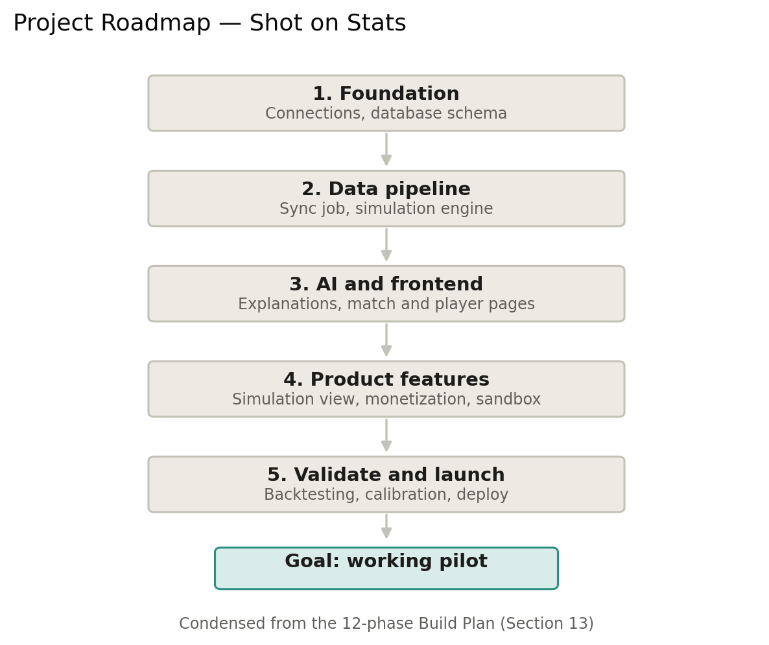
The 12-phase table below is the detailed version of the same five stages shown above.
Phase | What Gets Built | Deliverable / Check
1. Connection scaffolding | Project structure, environment variables, frontend/backend/database wired together with no feature logic yet | A health-check page confirms the database connection works
2. Database schema | All tables from Section 6 (teams, players, fixtures, predictions, player_predictions, calibration_log, users) | Tables exist and can be queried, even with placeholder rows
3. Data sync layer | Daily sync job pulling from API-Football and ClubElo (Section 11's event-driven design), writing into the schema from Phase 2 | One real league's teams and fixtures appear in the database
4. Simulation engine | The Elo → expected goals → Poisson → Monte Carlo pipeline (Section 3.3), as a standalone, testable module | Given two Elo ratings, the engine returns a win/draw/loss split and goal distribution matching the worked examples in Section 3.3
5. AI explanation layer | Generation call plus the second-model review pass (Section 4), reading simulation output and writing back to the database | A real fixture gets a stored, human-readable explanation
6. Match page (team level) | Frontend view showing Elo, win/draw/loss bar, predicted score, and the AI explanation (Section 5.1) | One real upcoming match renders correctly end to end
7. Player projections | Per-90 rate, opponent adjustment, form blend (Section 3.2), plus the player table UI (Section 5.2) | A full squad's projections display, with "not enough data" handled correctly
8. Simulation visualization | Per-team headline number plus distribution chart (Section 5.4) | Matches the mockup already built for the pitch
9. Monetization gating | 3-matches-per-week free cap, ad slot, simulated Premium upgrade (Section 7), custom match sandbox with its separate 3-per-day quota (Section 5.6) | Free and Premium accounts behave differently in the UI
10. Testing & validation | Backtest the simulation engine against historical World Cup data (Section 9), compute accuracy metrics | A Brier score exists for the model, even if it's not yet great
11. Calibration (stretch) | Automated parameter search against the Section 9 backtest (Section 10), with logging to calibration_log | Running calibration measurably improves the Brier score from Phase 10
12. Deploy & polish | Push to the hosting stack from Section 11, fix rough edges, prepare demo data for the pitch | The live site is reachable at a public URL
Phases 1–7 form the minimum needed for a working demo; Phases 8–12 round out the full pitch but could be trimmed or shown as "in progress" if time runs short before the presentation.

14. Why This Is a Strong Pitch
- Clear separation of concerns: a real, explainable statistical model (Elo) drives predictions; AI adds value on top rather than being a black box making the call.
- Verifiable and honest: showing past predictions next to actual results builds public trust and is a strong, visible differentiator.
- Extensible: Elo ratings and player projections are a proven, well-understood approach in sports analytics, giving room to grow into more sophisticated modeling later without starting over.
- A believable path to a custom AI model over time, rather than permanent dependency on a third-party AI API.
- Honest about its own limitations, which is more credible than a pitch that claims everything already works perfectly.
- A carefully scoped, cost-aware data plan — coverage decisions are grounded in real request budgets, not hand-waved.

